Practical 3: Sorting Algorithms: Comparison-Based, Counting-Based, and Digit-Based Strategies
Practical Aim
To implement and compare multiple sorting algorithms and develop the ability to reason about which sorting strategy suits a given situation.
Problem 1
Problem Statement
A teacher has a stack of student answer sheets with marks written on them and needs to arrange them in order before entering grades. She tries three different methods: in the first, she repeatedly compares adjacent sheets and swaps them if they are out of order; in the second, she finds the lowest-marked sheet each time and places it at the front; in the third, she picks each sheet one by one and inserts it into its correct position among the already-arranged sheets. Implement all three methods and for each one, print the sorted order of marks.
Describe how each of the three methods works in your own words. If the sheets were already in order before the teacher started, which method would finish the fastest and why?
Code
#include <iostream>
using namespace std;
int main()
{
int n;
int temp;
cout << "Enter size of Sheet: ";
cin >> n;
int a[n];

cout << "Enter sheet no.: ";
for (int i = 0; i < n; i++)
{
cin >> a[i];
}

// ----------------------------------method 1-------------------------------------
// for (int i = 0; i < n; i++)
// {
// for (int j = i+1; j < n; j++)
// {
// if(a[i]>a[j]){
// temp = a[i];
// a[i] = a[j];
// a[j] = temp;
// }
// }
// }

// ----------------------------------method 2---------------------------------------
// for (int i = 0; i < n; i++)
// {

// int min = a[i];
// int min_i = i;
// for (int j = i+1; j < n; j++)
// {
// if (a[j] < min)
// {
// min = a[j];
// min_i = j;
// }
// }

// temp = a[i];
// a[i] = a[min_i];
// a[min_i] = temp;
// }

// ----------------------------------method 3---------------------------------------
for (int i = 1; i < n; i++)
{
int temp = a[i];
int j;

for (j = i - 1; j >= 0 && a[j] > temp; j--)
{
a[j + 1] = a[j];
}

a[j + 1] = temp;
}

cout << "Shorting: ";
for (int i = 0; i < n; i++)
{
cout << a[i] << " ";
}

return 0;
}
Output
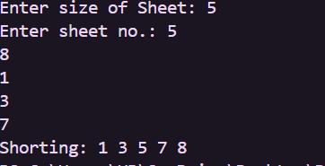
Problem 2
Problem Statement
A paint shop has buckets labeled with one of three colour codes—0, 1, or 2—but they are stored in random order. The shop owner wants all 0s together, then all 1s, then all 2s, without using any extra storage. Given the list of colour codes, rearrange them in place and print the result.
Describe the approach you used. Does your solution make more than one pass through the list? Can you think of a way to do it in exactly one pass?
Code
#include <iostream>
using namespace std;

int main()
{
int n;
int zero = 0, one = 0, two = 0;
cout << "How many items in shop: ";
cin >> n;
int a[n];

for (int i = 0; i < n; i++)
{
cin >> a[i];
}

for (int i = 0; i < n; i++)
{
if (a[i] == 0)
zero++;
else if (a[i] == 1)
one++;
else
two++;
}

int j=0;

for (int i = 0; i < zero; i++)
{
a[j++]=0;
}
for (int i = 0; i < one; i++)
{
a[j++]=1;
}
for (int i = 0; i < two; i++)
{
a[j++]=2;
}

for (int i = 0; i < n; i++)
{
cout << a[i] <<" ";
}

return 0;
}
Output
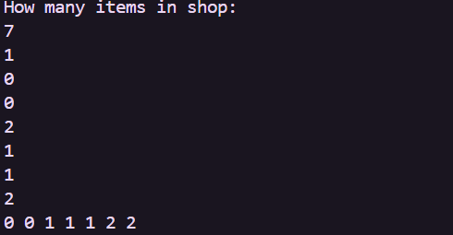
Key Questions / Analysis / Interpretation to be Evaluated During/After
Implementation
1. [Problem 1] One of the three methods can detect early that the list is already sorted and stop without doing any more work. Which method is it, how would you add that
detection, and why can the other two not do the same?
Answer: Bubble Sort can detect if the list is already sorted by checking whether any swap happened. If no swap occurs, it stops early.
2. [Problem 2] If your solution makes two passes through the list, can you identify which decision in your logic forces the second pass? Is there a way to restructure that decision to eliminate it?
Answer: The second pass is needed when we first find or count something and then process it again. We can combine both steps into one loop to avoid the second pass.
Conclusion:
• Learned Bubble Sort, Selection Sort, and Insertion Sort.
• Compared the performance of different sorting algorithms.
• Implemented sorting programs in C++.
• Verified outputs using sample test cases.

